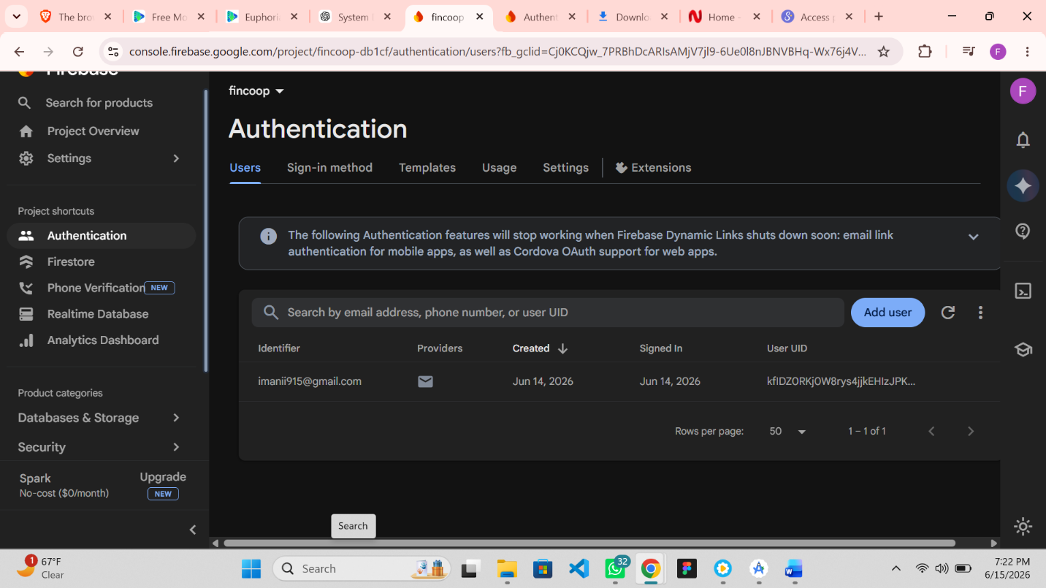

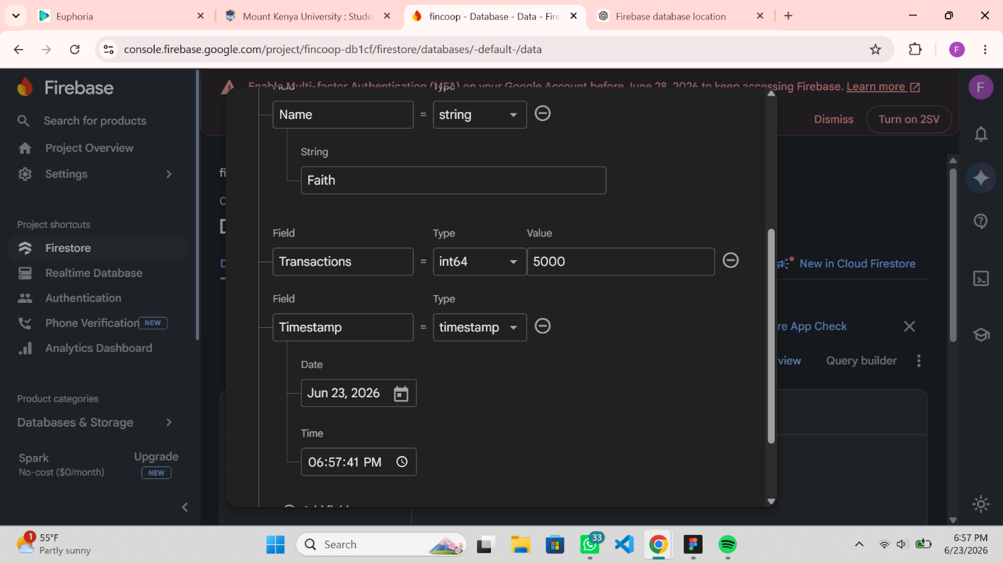
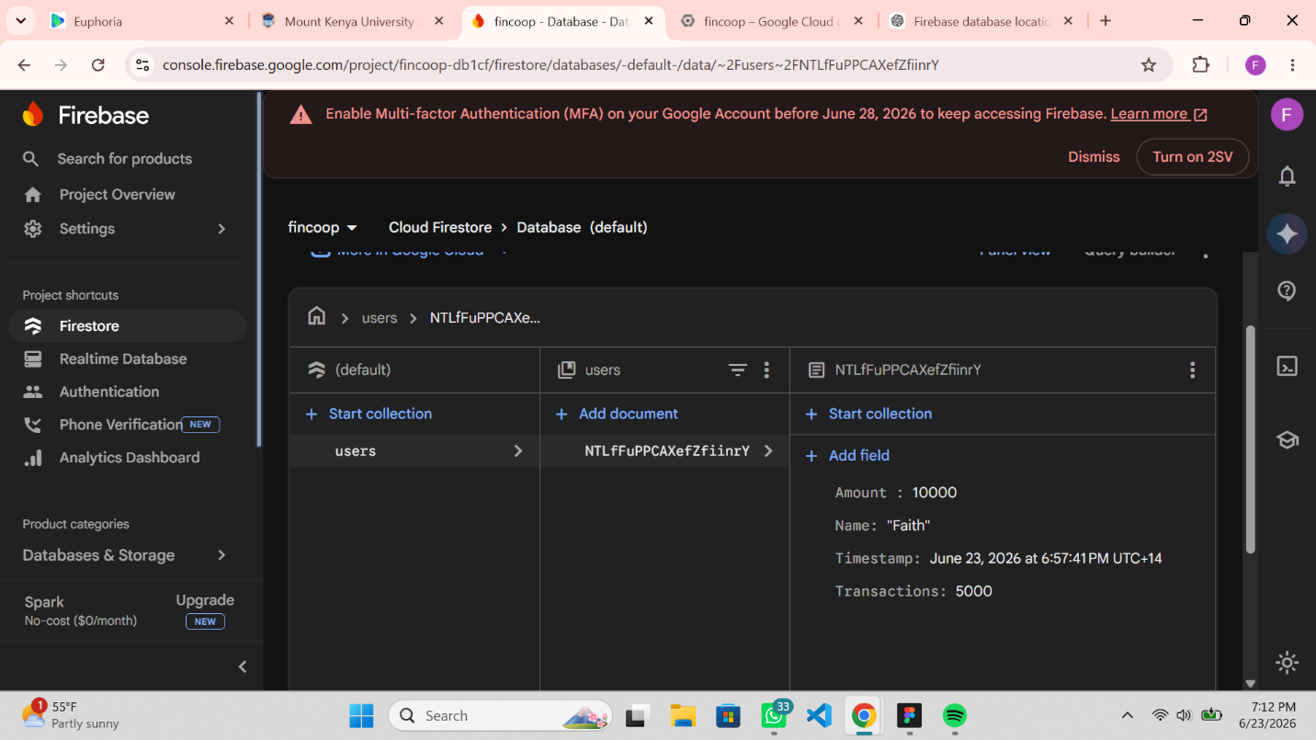

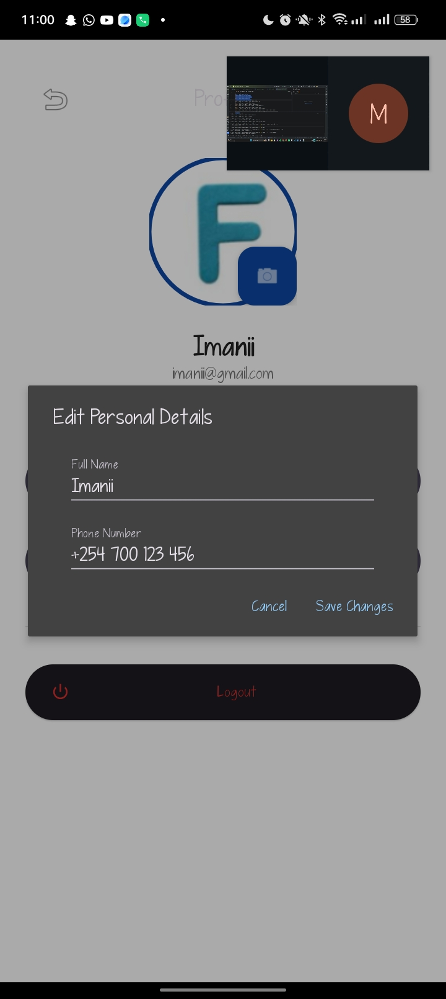

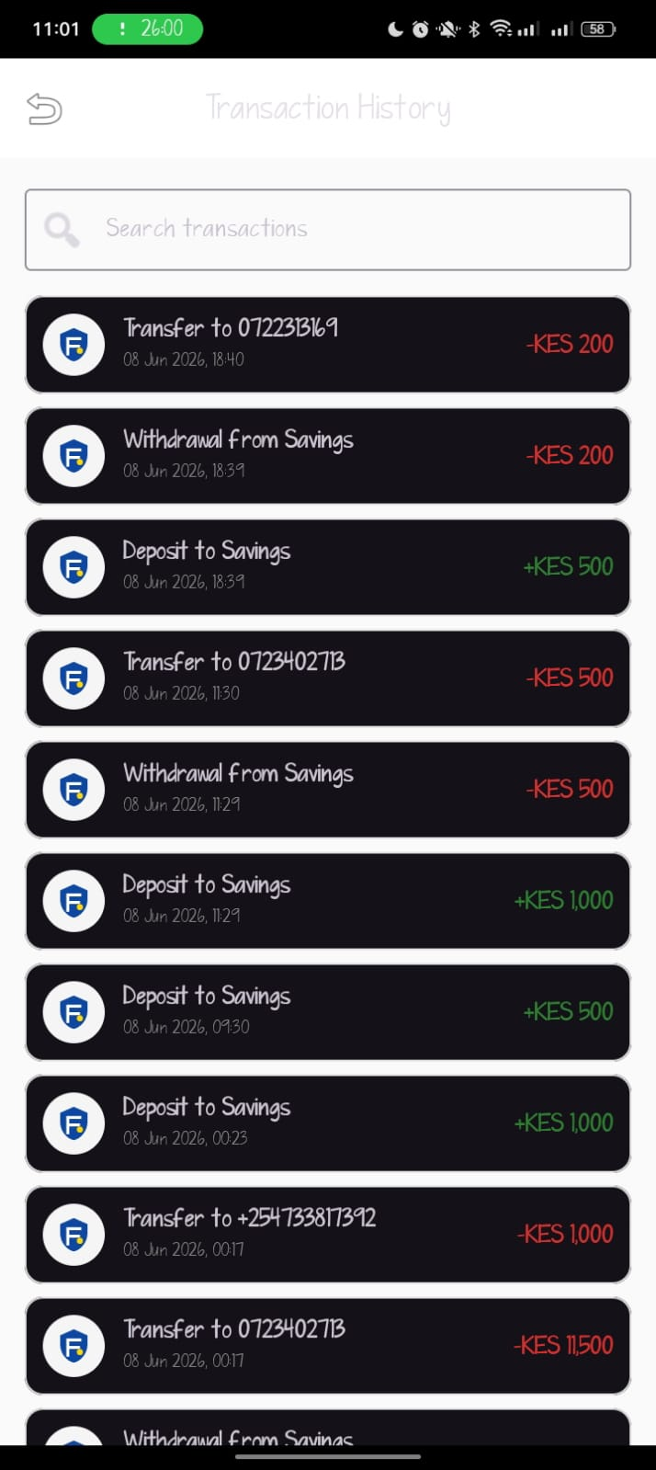
Personal reflection
I successfully integrated my application with Firebase, enabling users to register and securely store their information. I implemented features that allow users to view their data and recent transactions directly from the app. This experience improved my understanding of Firebase integration, authentication, and database management.

